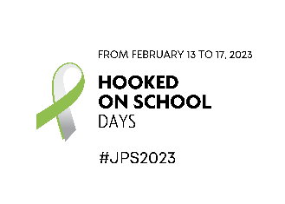
Campaign text

From February 13 to 17, 2023, Hooked on School Days pays tribute to all the people in young Quebecer’s lives who make a difference. We recognize their crucial role in students’ motivation, resilience, and self-confidence, and we salute their commitment to making perseverance at school a priority. Their congratulations, guidance, encouragement, explanations, sympathetic ear, and support are of great benefit to young people, and indeed to all of society.
Students develop a sense of perseverance at school through the kindness of those around them. Behind every young person who works hard at school are adults who play a vital role, and you are one of them.
The young people in our lives face many challenges in their day-to-day lives. Think, for example, of students who feel inadequate or fear that because of the pandemic, their diploma or qualification is less valuable in the eyes of employers, a situation that has unfortunately exacerbated the mental health problems of far too many Quebec youth. There are also students who hold down jobs while attending school. Working has its benefits, but any imbalance between time spent studying and time spent at work exposes these students to risks such as reduced motivation.
Let’s continue to support students and praise their efforts to help them stay the course and shape a future in which they experience academic success. Because watching them succeed is worth its weight in gold!
The more you can do to instill a sense of confidence and self-worth, the better the chances that Quebec youth will achieve their potential and find the strength to move forward in a direction that reflects their passions and interests. And this self-confidence is very likely to then be passed on from generation to generation.
Whether you’re a parent, teacher, educator, employer, school specialist, support staff, or you work in a community organization, your actions and your caring presence unquestionably increase the likelihood of a student’s success at school.
Your familiar and comforting face gives young people a boost and helps them persevere. And all it takes is small, everyday gestures that help remove the barriers to educational success, such as:
- Offering to help
- Taking an interest in what happens at school
- Listening
- Giving them their first taste of success in an extracurricular activity
- Suggesting resources for managing time spent at school, leisure, and work
- Encouraging them to stick with it until they earn their diploma or qualification
- Offering positive reassurance

Let’s all stay committed and engaged in the caring and collective movement that is Hooked on School Days. And let’s keep doing what we do best for our young people – making a difference. Because with the right support, everyone can persevere.

